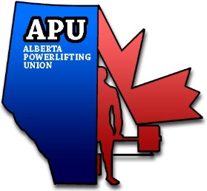
Alberta Powerlifting Union

PAGM Proposal

NAME:
CITY:
PHONE:
EMAIL:

PROPOSAL:

REASON:

PREVIOUS BYLAW OR POLICY (IF APPLICABLE):

EMAIL TO: ALBERTA.POWERLIFTING.UNION@GMAIL.COM

